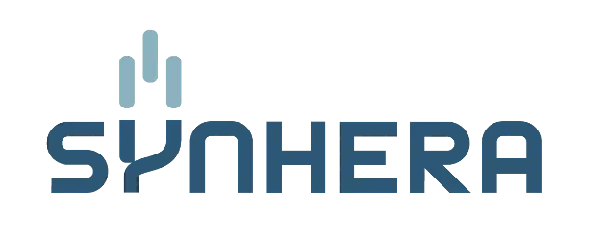
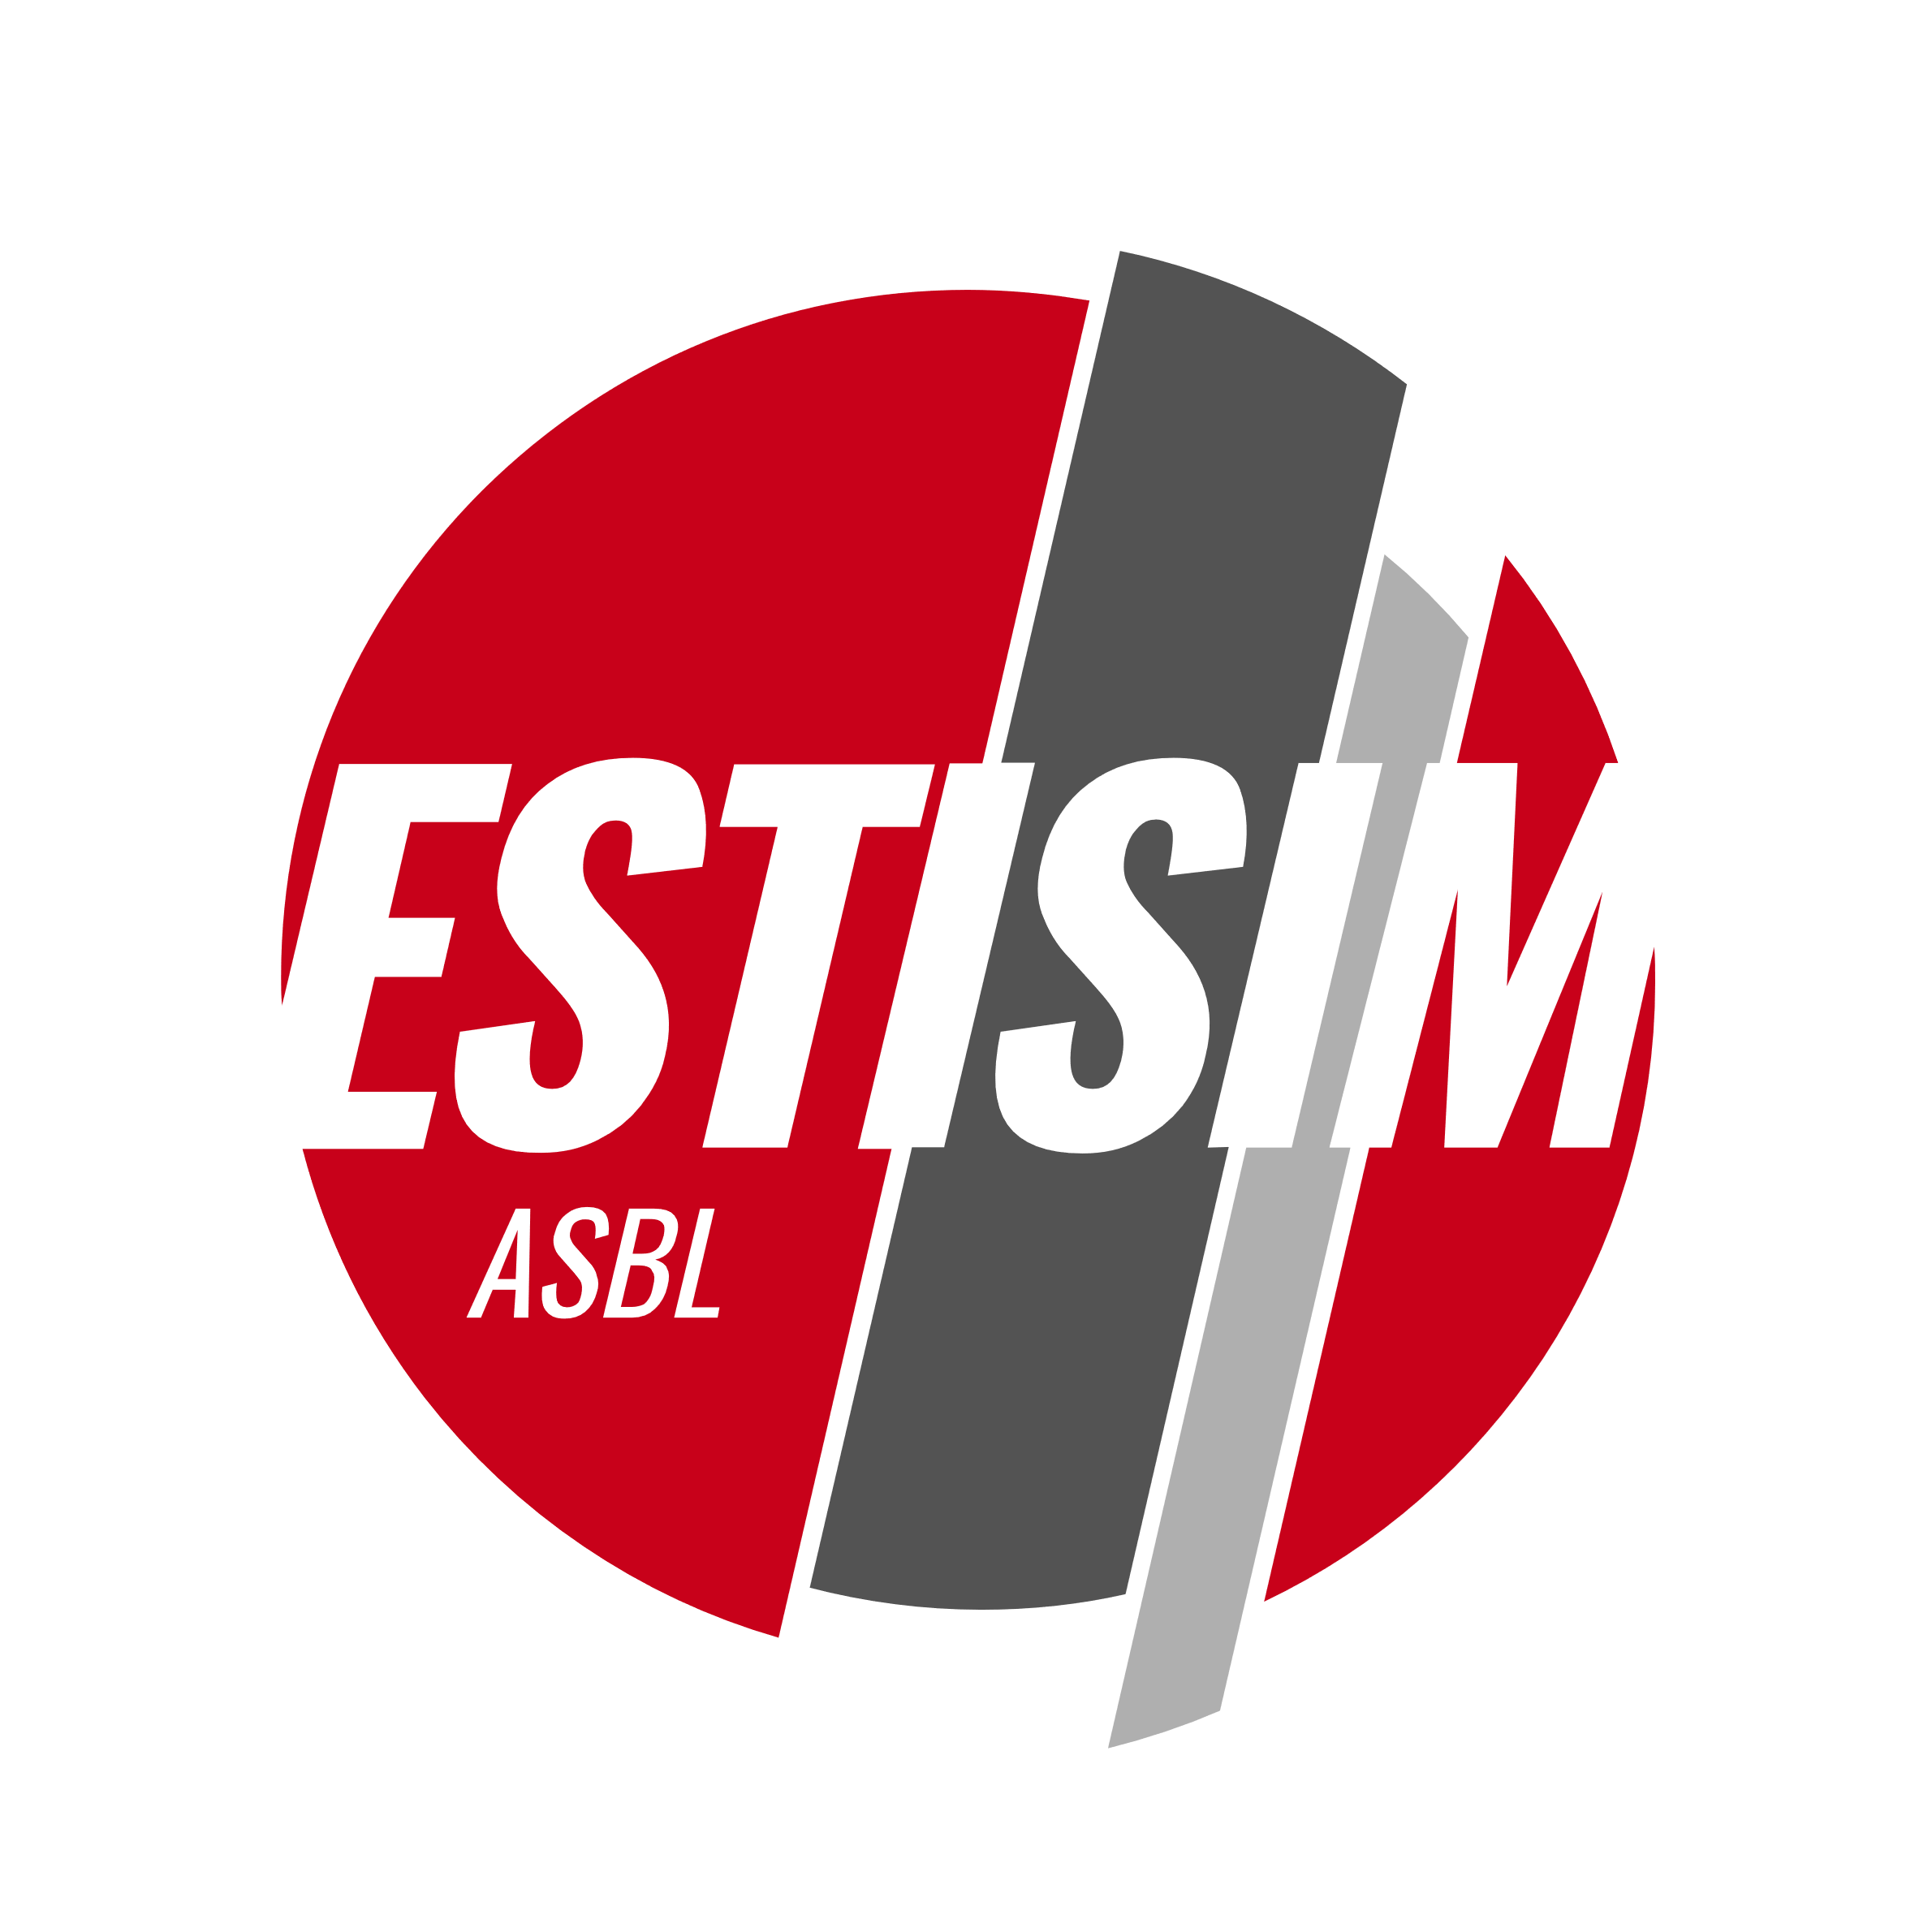

Date : 24-06-2025

Internship/Master Thesis Proposal at Haute Ecole en Hainaut (HEH.be)
Location: Power Electronics and Plasma Processes Laboratory (P³LAB), Department of Science and Technology, Avenue Maistriau 8A, B-7000 MONS
Dates: 1st or 2nd semester of the 2025–2026 academic year (flexible)
Topic: Development of a software core for the synchronized control of power transistors
Profile: Master’s degree in Electrical Engineering or Master’s degree in Industrial Engineering with a specialization in Computer Science/Electronics

This internship is part of the applied research project OptiDBD (funded by the Programme de Recherche en Hautes Écoles, 2024–2026), launched in October 2024 at HEH.be.
The project focuses on the optimization of dielectric barrier discharges (DBDs), which generate plasma at near-atmospheric pressure and are widely used in surface treatment. Currently, DBD reactors are typically powered by sinusoidal AC voltage sources with variable amplitude and frequency. However, recent studies have highlighted the benefits of replacing this power supply with a current source, offering better control of the power delivered.
Whereas quasi-sinusoidal alternating currents are commonly used in such processes, we are developing a programmable waveform current source. This innovative approach could improve process efficiency by 20 to 30%.
The STM32 NUCLEO-G431RB development board is used, together with the STM32CubeIDE environment. Two main objectives are pursued:
- The design of a human–machine interface (HMI) using a Nextion display;
- Programming the STMicroelectronics DSP to generate 32 synchronized TTL signals for producing the desired output voltage.
The work will follow these steps:
- Literature review on the state of the art;
- Advanced modeling of switching systems (PSIM or Matlab/Simulink);
- Design and development of a human–machine interface;
- Programming of the software core, with verification of the signals using a 32-channel logic analyzer;
- Testing and measurement phase to validate system performance.
This internship requires the ability to work independently in a laboratory environment, including literature research, equipment handling, and programming. Pedagogical and technical resources will be provided to support the student. At the same time, close collaboration with the project researcher is expected, fostering a dynamic and enriching teamwork experience.

